**CI/CD Pipeline: Building and Pushing Docker Images from GitHub to Docker Hub Using GitHub Actions**

***Prerequisites***

Before starting, make sure you have:

* A GitHub account
* A Docker Hub account
* Docker installed locally (for testing)
* Your project hosted on GitHub (e.g., a simple Spring Boot App with a Dockerfile)

***Step 1: Create a “Dockerfile” in Your Project***

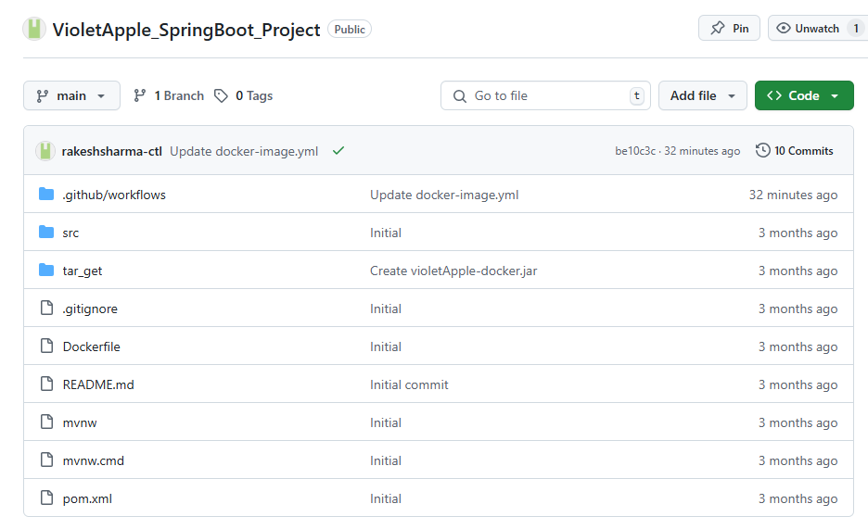

1. # 1️Use an official Java runtime as the base image

2. FROM openjdk:17-jdk-slim

3.

4. # 2️Set the working directory inside the container

5. WORKDIR /app

6.

7. # 3️Copy the built JAR file into the container

8. COPY target/violetApple-docker.jar app.jar

9.

10. # 4️Expose the application port

11. EXPOSE 8080

12.

13. # 5️Run the application

14. ENTRYPOINT ["java", "-jar", "app.jar"]

**Step 2: Create a Repository on GitHub**

If you haven’t already:

1. Push your local project to GitHub
2. Make sure the Dockerfile is in the root or specified directory

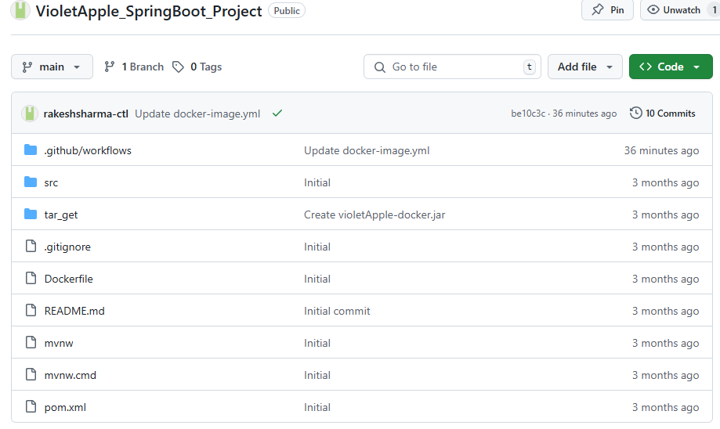

A typical GitHub repository root view

**Step 3: Store Docker Hub Credentials as GitHub Secrets**

Go to your GitHub repo → Settings → Secrets and variables → Actions → New repository secret

Add these secrets:

|  |  |
| --- | --- |
| **Name** | **Value** |
| DOCKER_HUB_TOKEN | Your Docker Hub username |

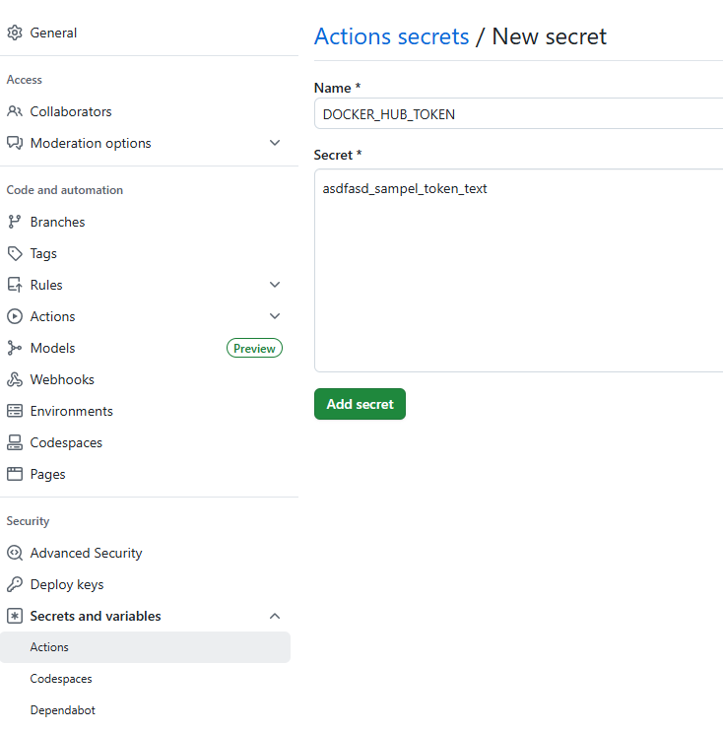

**Step 4: Create GitHub Actions Workflow**

In your repo, create this file:

1. .github/workflows/docker-image.yml

Sample “docker-image.yml” for a SpringBoot Application

1. name: Docker Image CI

2.

Action workflow gets executed when push or pull request is initiated in “main” branch.

3. on:

4. push:

5. branches: [ "main" ]

6. pull_request:

7. branches: [ "main" ]

8.

We have used ubuntu latest version as operating system.

9. jobs:

10. build-and-push:

11. runs-on: ubuntu-latest

12.

13. steps:

14. - name: Checkout Code

15. uses: actions/checkout@v4

16.

17. - name: Set up JDK 17

18. uses: actions/setup-java@v3

19. with:

20. java-version: '17'

21. distribution: 'temurin'

22.

23. - name: Build with Maven

24. run: mvn clean package -DskipTests

25.

26. - name: Log in to Docker Hub using CLI

27. run: docker login -u sharmarakesh -p ${{ secrets.DOCKER_HUB_TOKEN }}

Docker token stored in Action secrets

28.

Github username

29. - name: Build Docker Image

30. run: |

31. docker build -t sharmarakesh/violetapple-springboot-project:latest .

32.

33. - name: Push Docker Image to Docker Hub

Name image always as latest.

34. run: |

35. docker push sharmarakesh/violetapple-springboot-project:latest

**Step 5: Commit and Push the Workflow**

Once the workflow YAML is committed and pushed to the main branch, it will automatically trigger the pipeline.

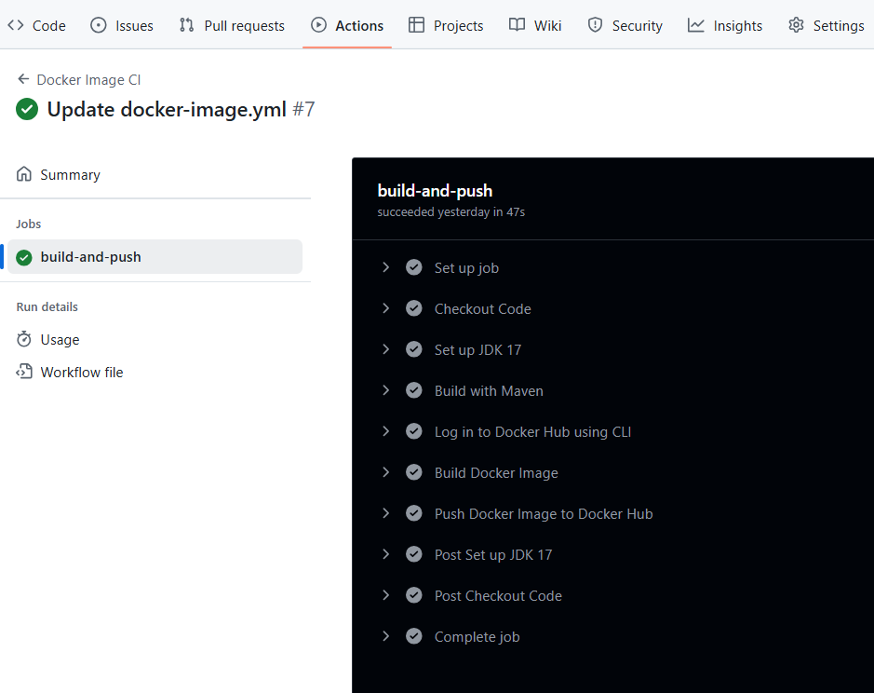

**Step 6: Confirm on Docker Hub**

Go to Docker Hub → Check your repository → The latest image should be pushed.

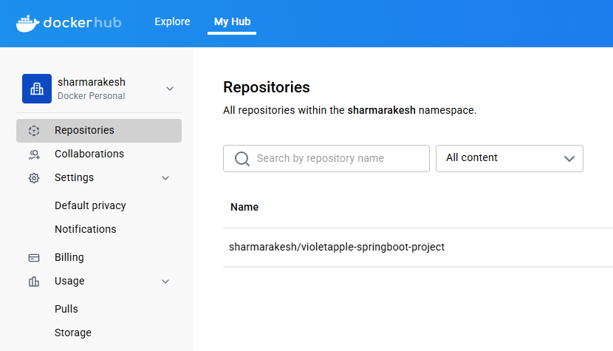

Latest image shown here

**Step 6: Test on Docker Desktop**

1. Once the image is pushed to Docker Hub, you can test it locally using Docker Desktop.
2. Pull the image from Docker Hub.

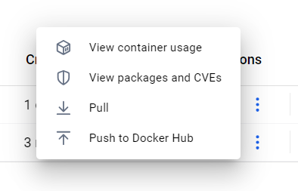

Click on the three dots to get Pull option.

1. Run a container from the image.

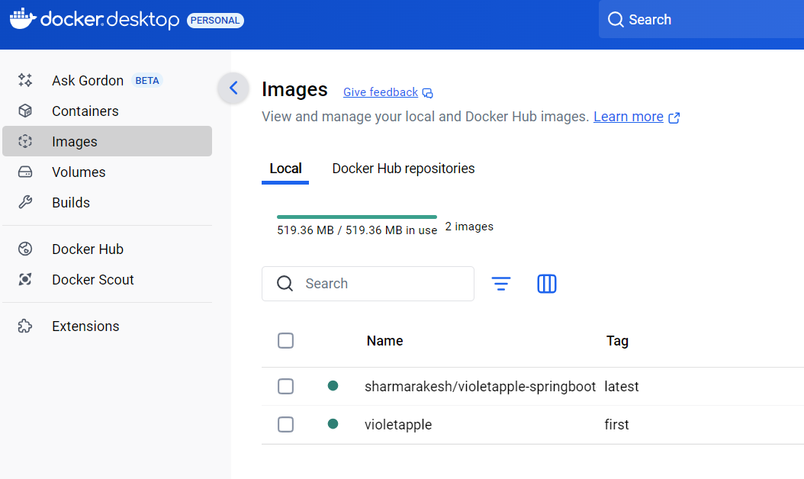

1. Open Docker Desktop to confirm the container is running.
2. Visit http://localhost:8080 (or your chosen port) in a browser to test the application.